***Exhaustive Analysis of Indian Agriculture Sector Using Power BI***

Week–1 Task

* Steps Followed
* Downloaded Microsoft Power BI Desktop from Microsoft website.

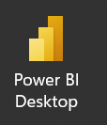

* Opened the Power BI workspace

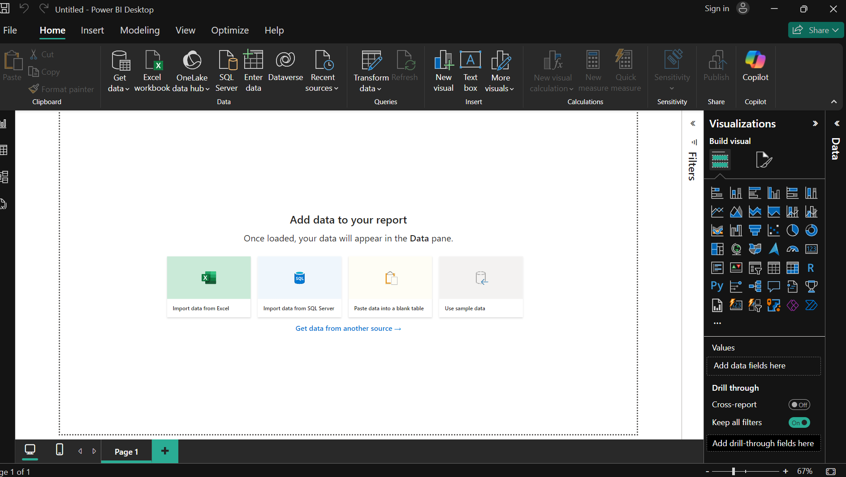

* Clicking on Get Data to obtain the desired data file.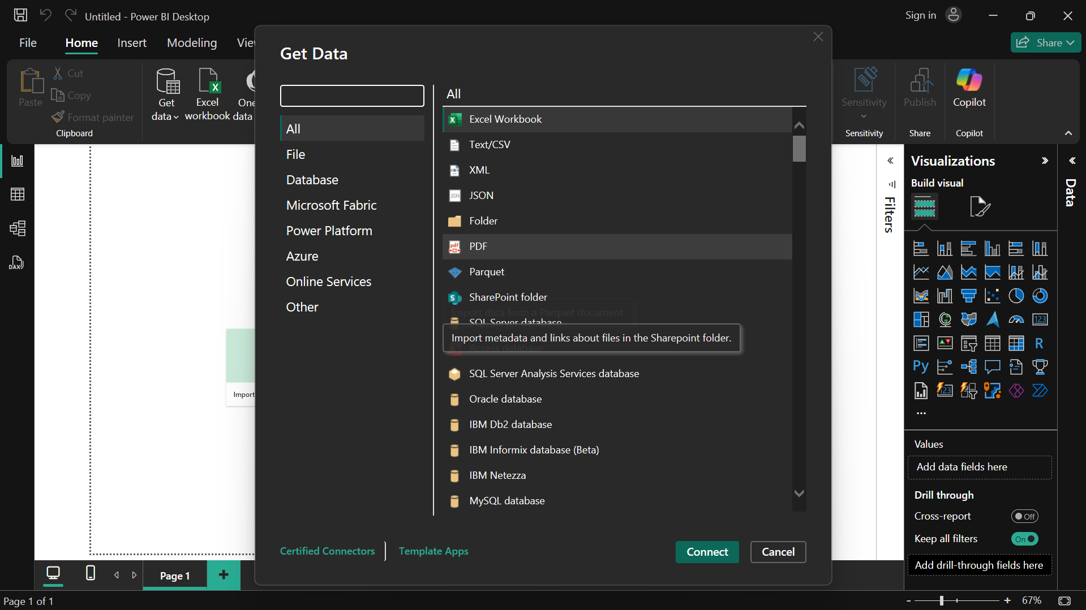
* Extracting, Transforming and cleaning the data:

Extract – Pull data from data source : excel, csv, text, database file.

Transform – Data processing , Data cleaning.

Load – For analysis.

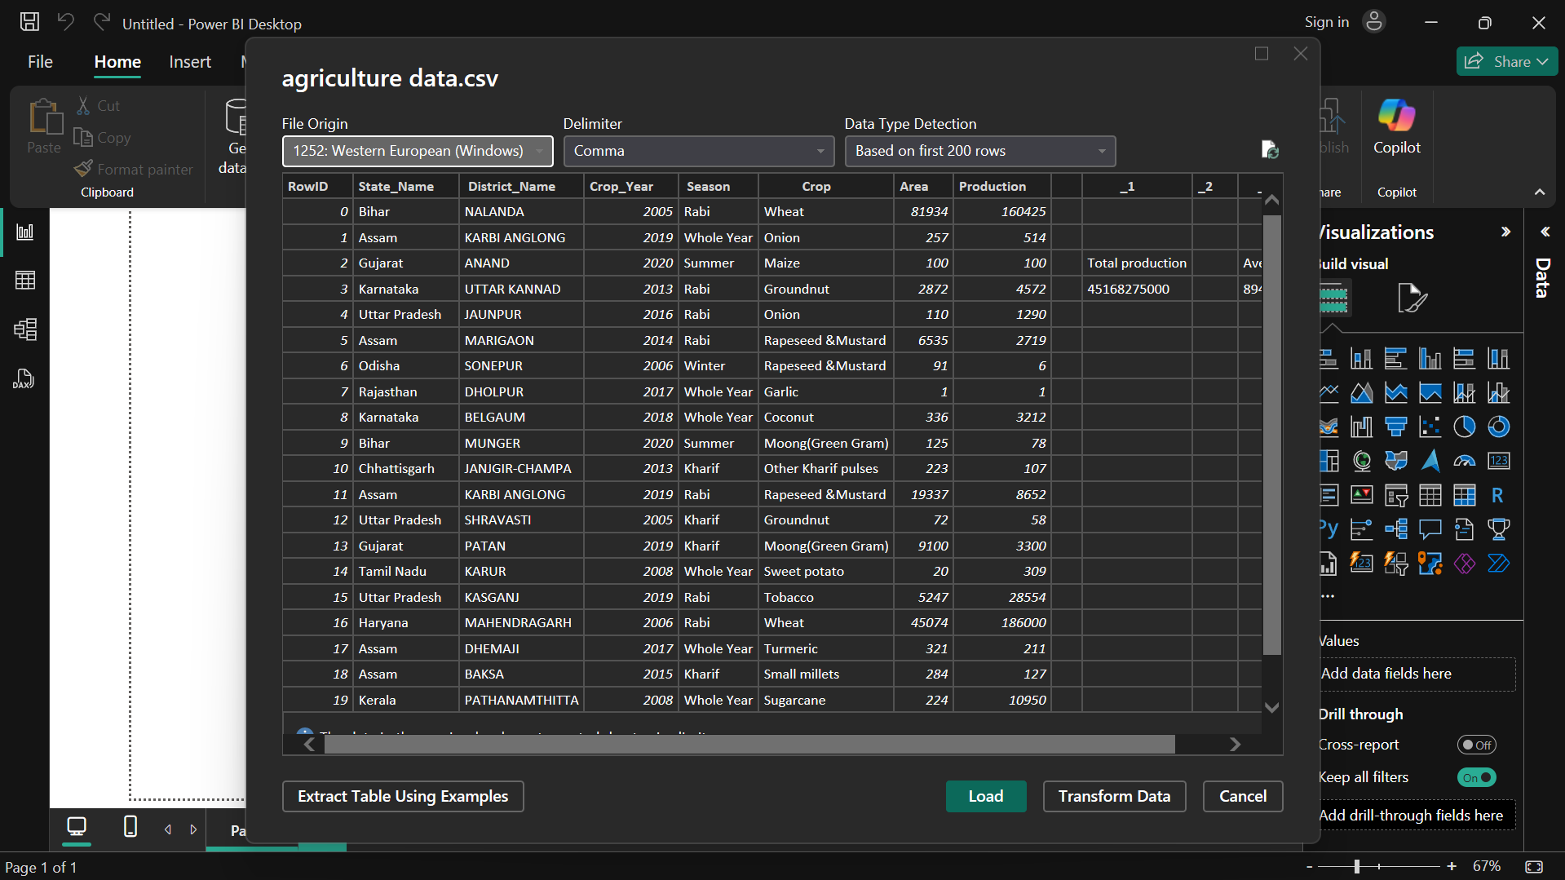

* Deleting the extra columns in power query editor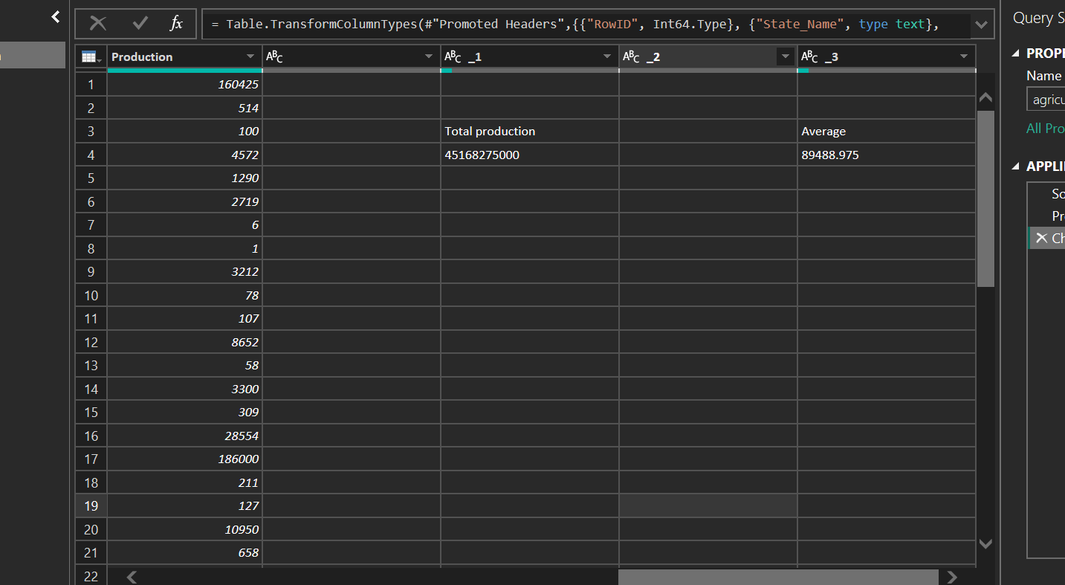

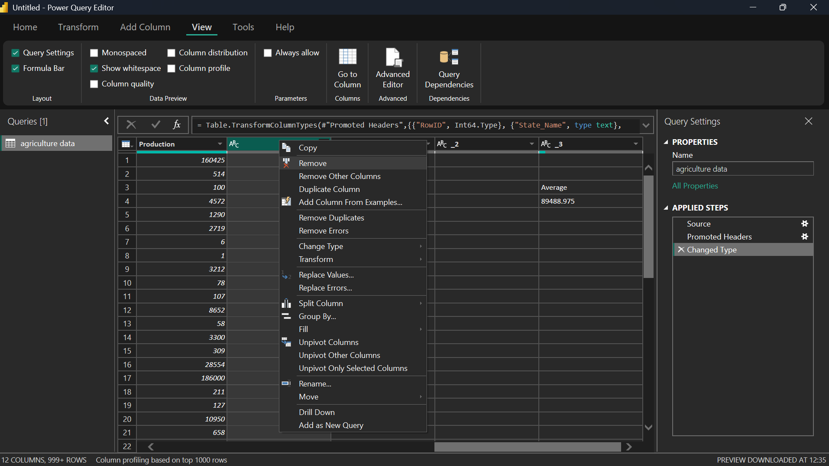

* Checking the Column Quality from the view menu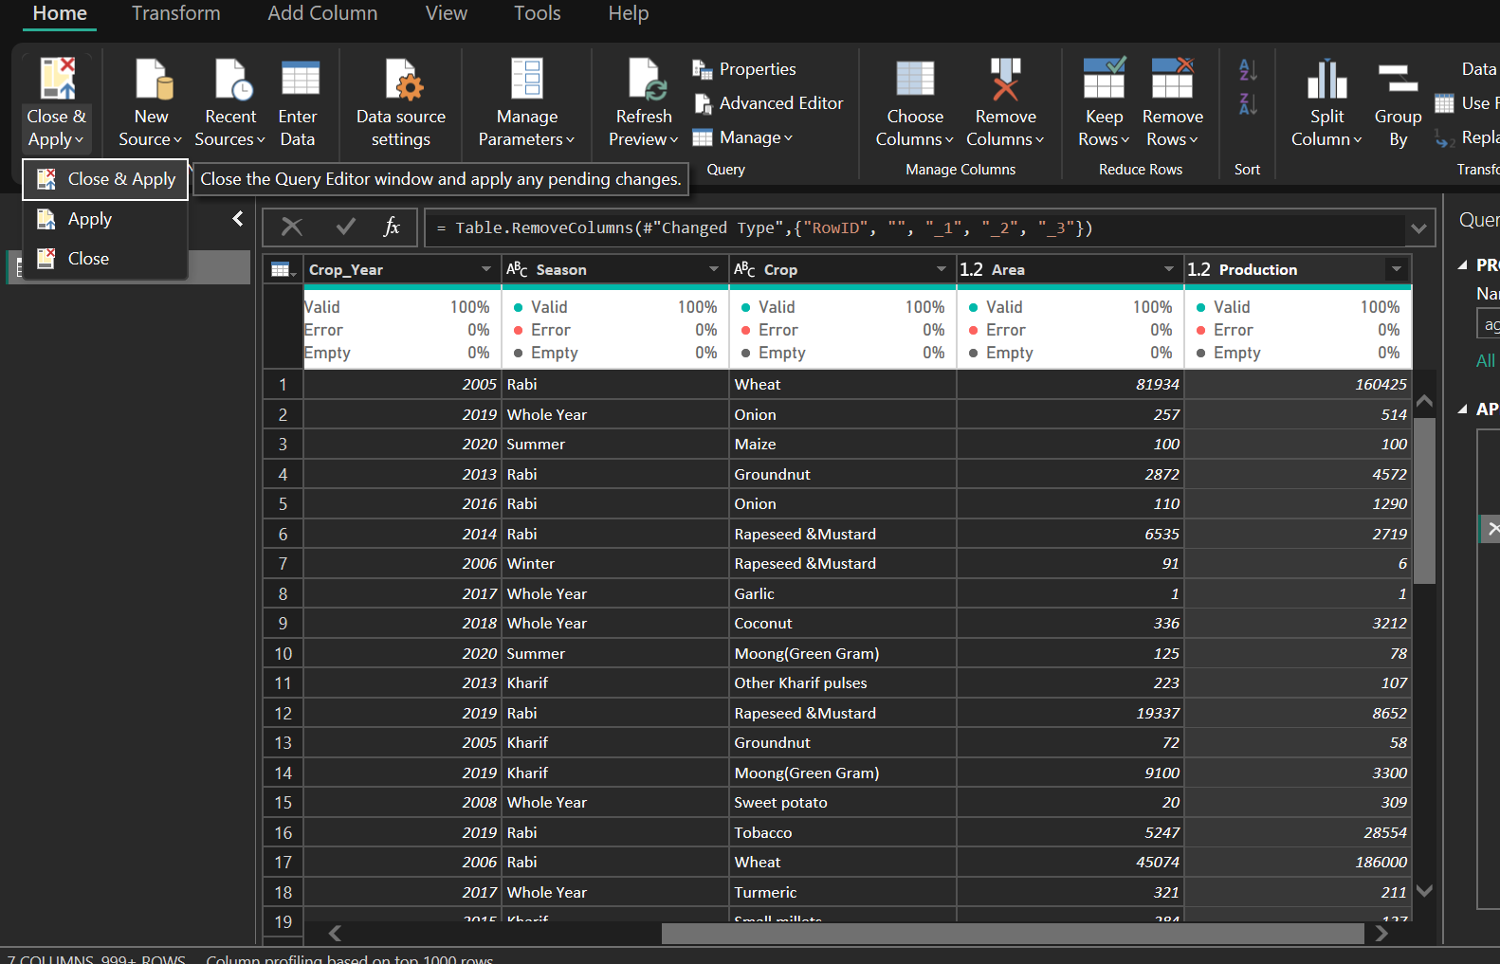
* After closing and applying the Power Query editor, the power BI apply the changes and load the data.

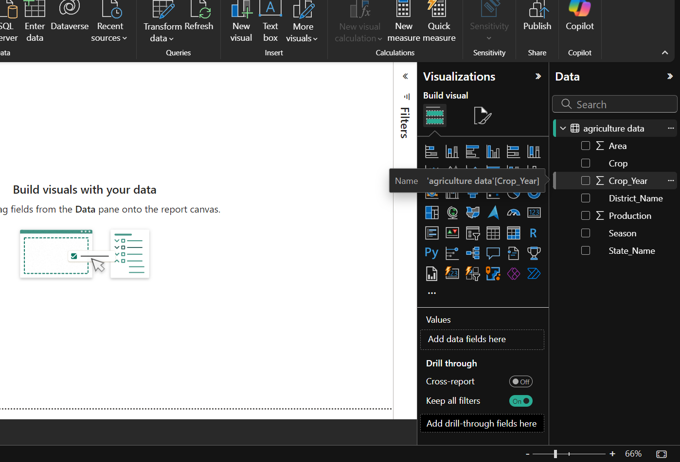

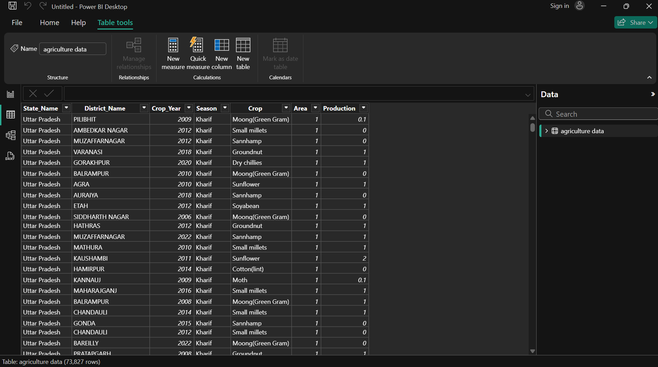

* We can see the data in the Report view , Table view and Model view.
  + - * Report view : for visualization
      * Table view : for seeing the data.
      * Model view: for creating relationship among data.



* This Power BI dashboard represents an analysis of agricultural data, focusing on the Sum of Area for different Indian states and districts.

Left Chart (Pie Chart):

* Shows the distribution of the total agricultural area by state.
* Key insights:
  + The largest area is contributed by specific states, such as Bihar, which dominates with 97.97% of the total share.
  + Other states like Karnataka, Madhya Pradesh, and Haryana have relatively smaller contributions.

Right Chart (Bar Chart):

* Displays hierarchical data:
  + First level: State-wise agricultural area (e.g., Bihar, Maharashtra, Haryana).
  + Second level: District-wise breakdown within each state (e.g., Nalanda district in Bihar).
* Bihar and its district, Nalanda, show significant contributions to the total agricultural area.

